1. Creating Repo on Github then pushing the changes on the repository

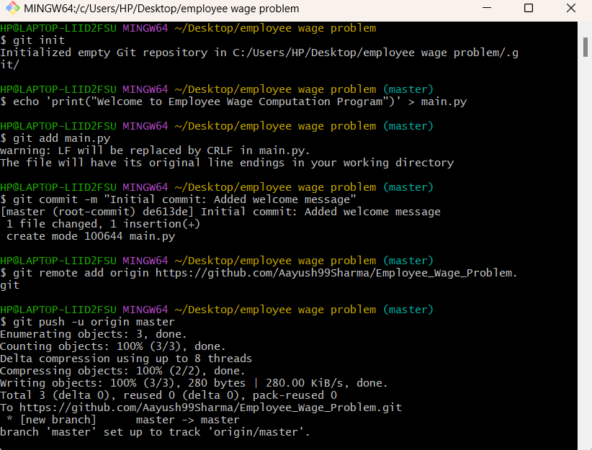

1. Creating UC1 branch and pushing the changes to UC1 branch

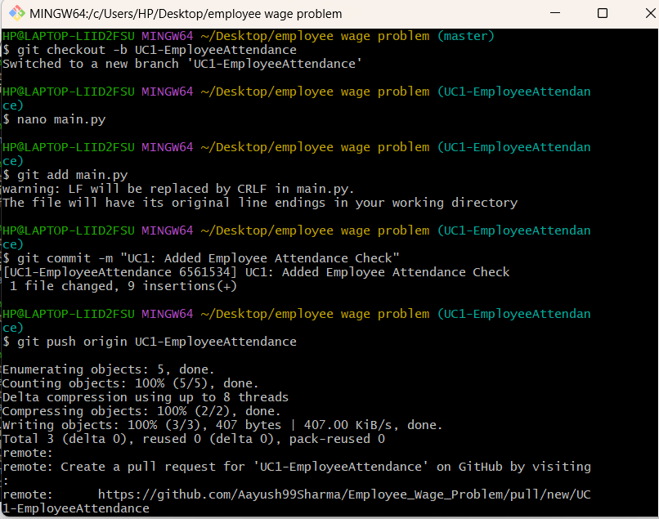

1. Merging UC1 branch with master branch

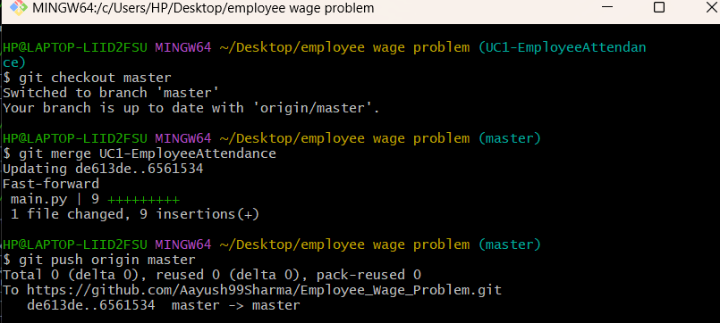

1. Creating UC2 branch and pushing all the changes to UC2 branch

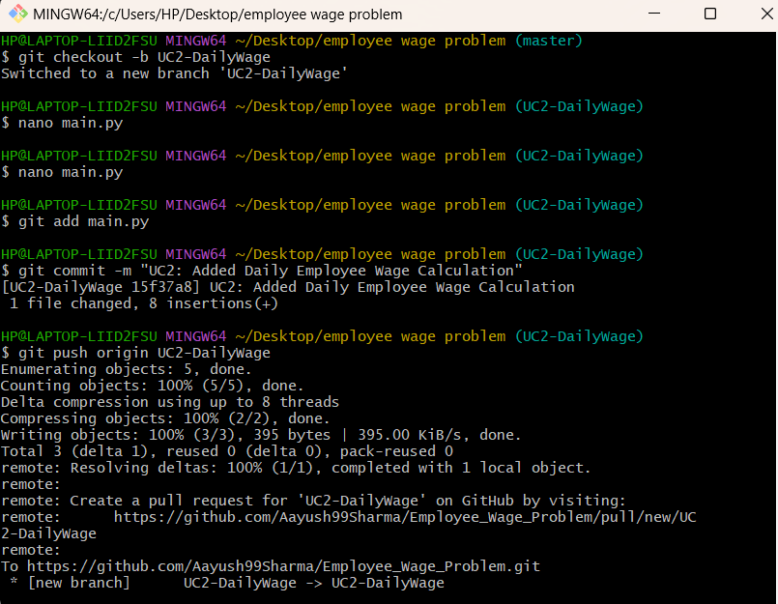

1. Merging UC2 branch with master branch

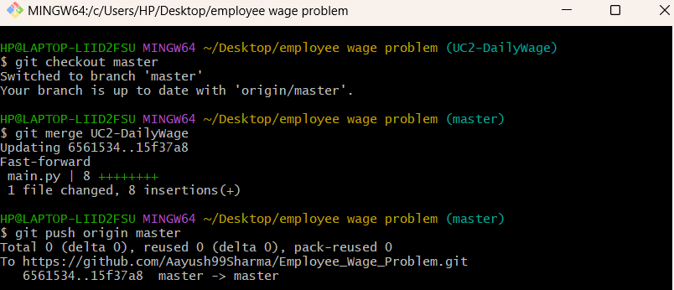

1. Creating UC3 branch and pushing all the changes to UC3 branch

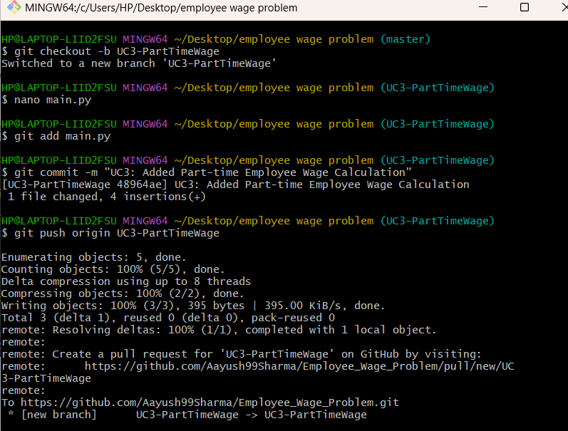

1. Merge UC3 Branch with Maste

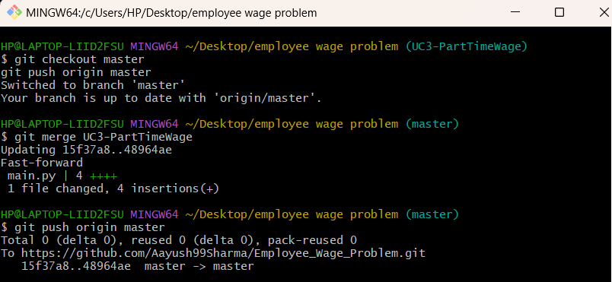

1. Creating UC4 branch and pushing all the changes to UC4 branch

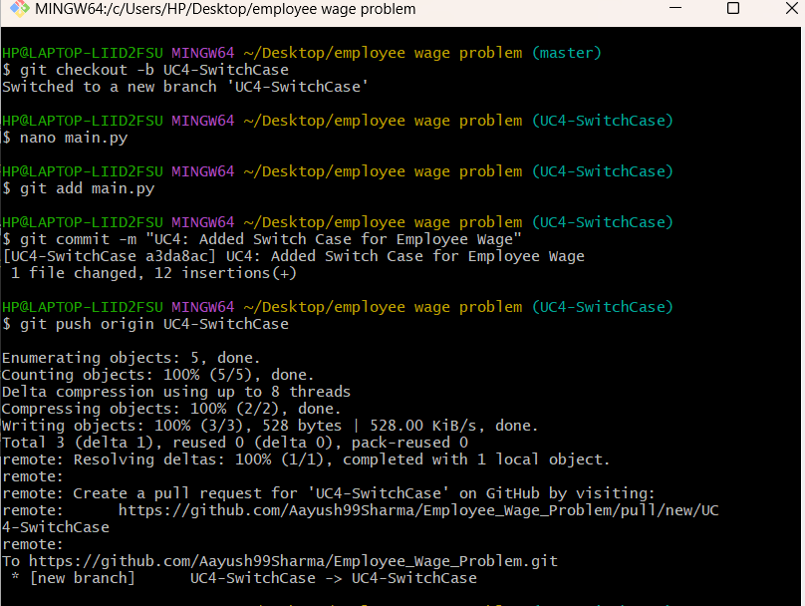

1. Merge UC4 with Master

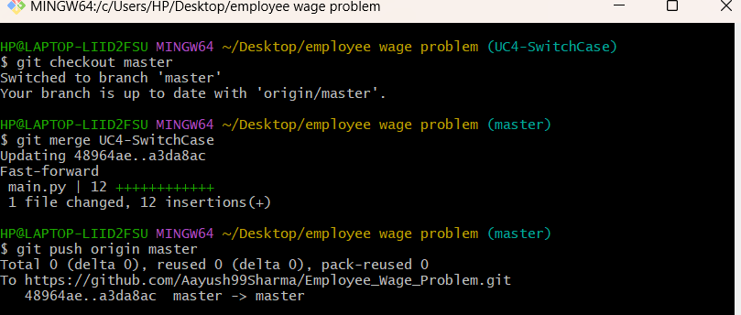

1. Create UC5 branch

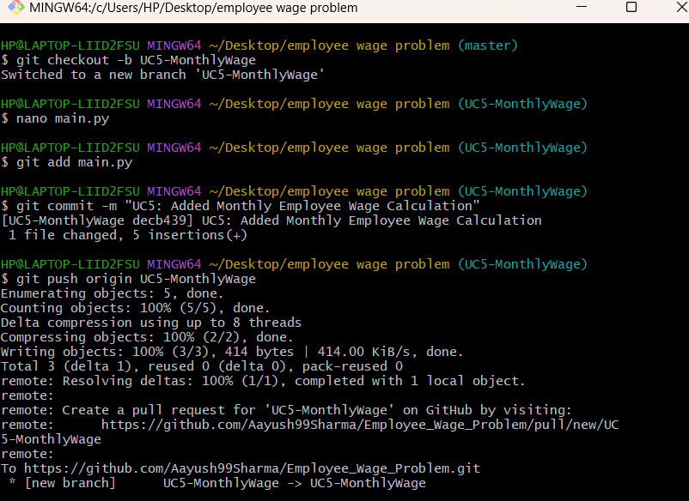

1. Merge UC5 with master

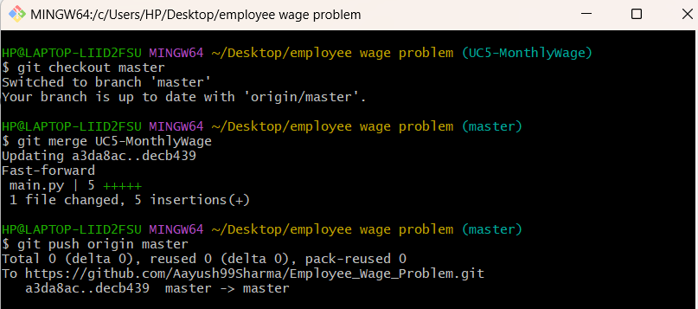

1. Create UC6 Branch

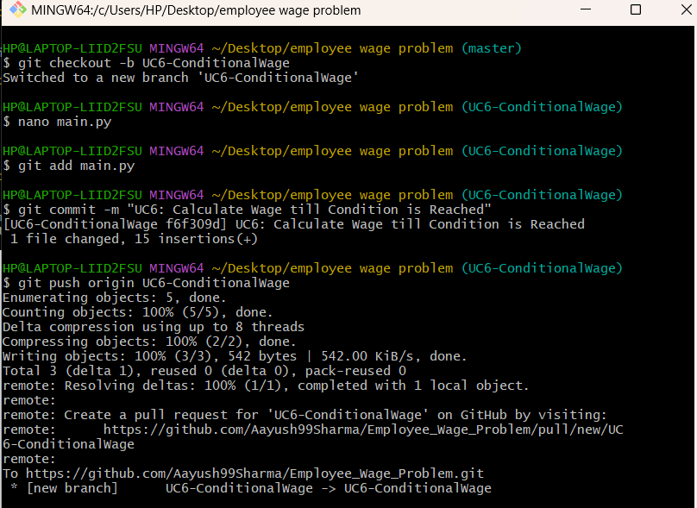

1. Merge UC6 with master

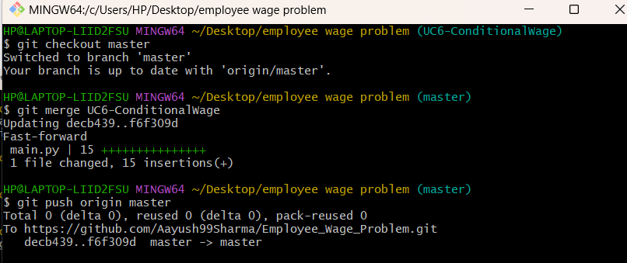

1. Create UC7 branch

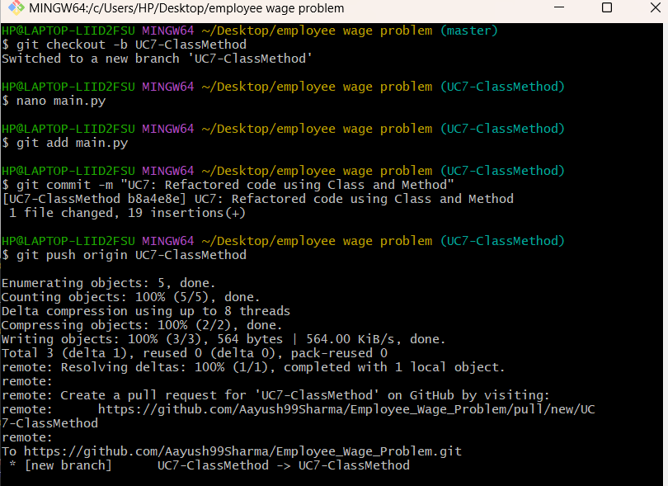

1. Create UC7 branch

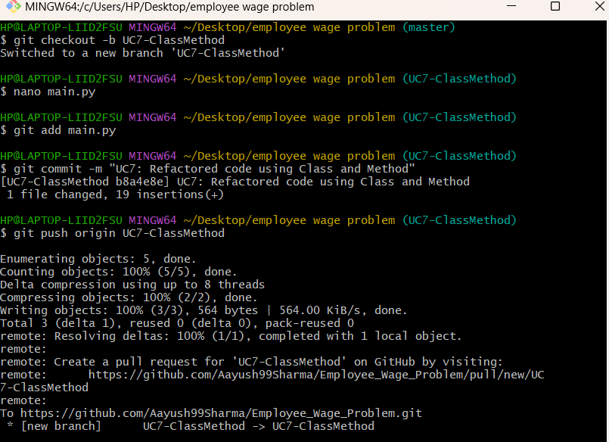

1. Merge UC7 with master branch

